Topic 2: Position, Distance and Distance
Objectives: At the end of this topic, students should be able to:
- Locate the position of a particle with respect to a reference frame.
- Determine the distance between two positions
- Determine the displacement between two positions
- Differentiate between distance and displacement.
CONTENT
POSITION:
- The position of a point in space is determined by its distance and direction from other points.
- To describe the position of a point, there must be a defining frame known as the “reference frame” also called “the origin”.
- Along a line, the origin is the zero point on the line.
Example1: Locate the position of the following points on a line:
- x = +2m
- y = +3m
- x = -2m
Solution:
- x = +2m
this means from the origin on x-axis move by 2m along the positive direction ( i.e to the right)

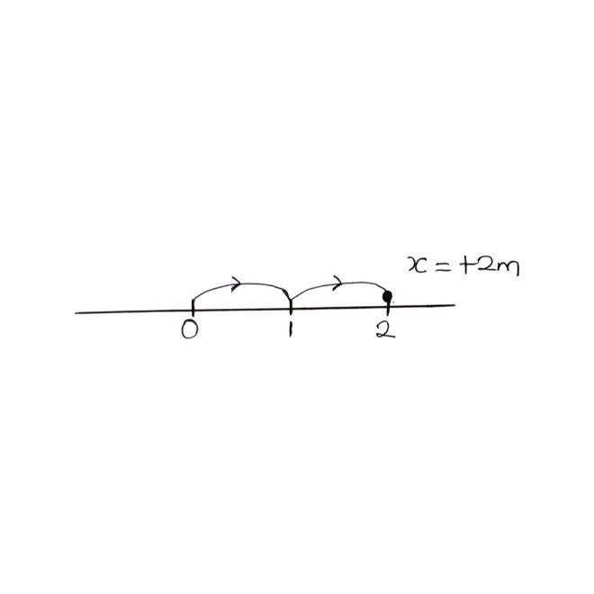
- y = + 3m
This means from the origin on y- axis move by 3m along the positive direction (i.e upward)
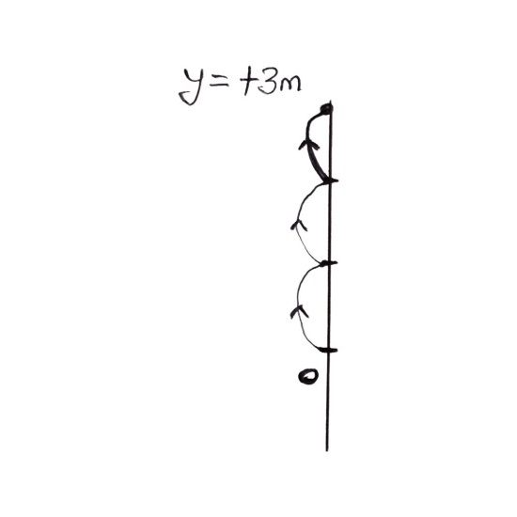

- x = -2m
This means from the origin on x-axis move by 2m along the negative direction(i.e. to the left)
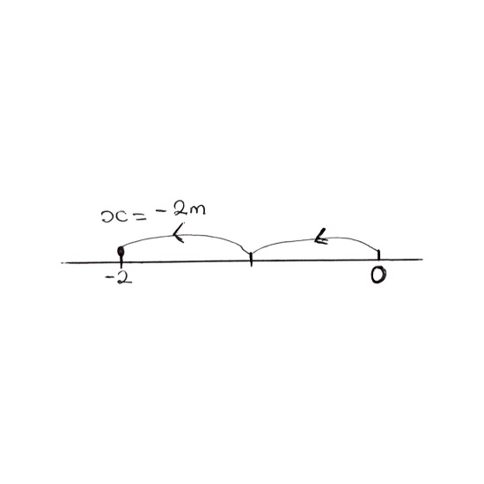

- In a plane, the origin is a point with coordinates (0,0)ssssssss
Example 2: Locate the following positions;
- A(2,3)
- B( -2, 1)
- C(2, -3)

SOLITION:
Note: The first number in the coordinate system represent x-component while the 2nd represents y- component.

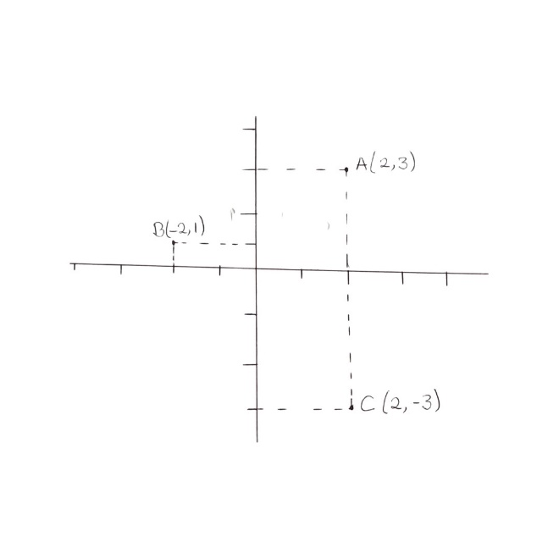
DISTANCE:
- This is the movement coverage of a body with no emphasis on its direction.
- It can simply be described as change in position of a body with no specific direction
- Its S.I. unit meters
DISPLACEMENT:
- This is the change in position of a body in a specified direction.
- It can be described as distance in a specified direction.
Example3: A particle moves from +2m position on x-axis to -3m and then to + 4m. find:
- The distance traveled by the particle
- The displacement of the particle
Solution:

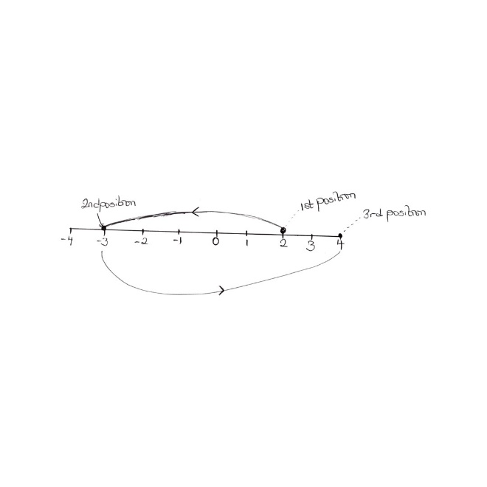
- Distance from 1st to 2nd position = 5
Distance from 2nd to 3rd position = 7
Total distance = 5+ 7
= 12m
- Displacement = Final position- initial position
= 3rd position – 1st position
= +4 – (+2)
= +2m
i.e. Displacement is 2m, in the positive x- direction
Example 4: A man walks 3m due North and then 4m due East. Find
- The distance covered by the man
- The displacement of the man

SOLUTION:
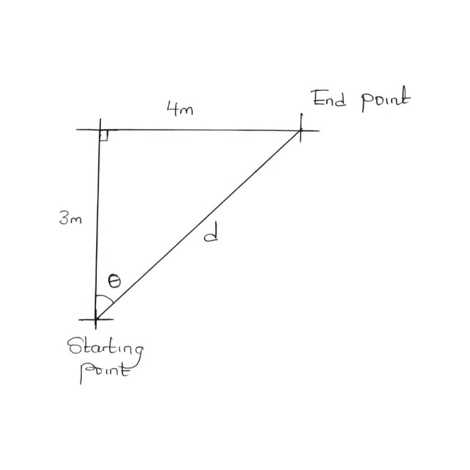
- Distance traveled = 3 + 4
= 7m
- Displacement is the shortest distance (d) from the starting point to the end point with bearing $θ$ indicated
Using Pythagoras:
$d^{2}=\left(4^{2}\right)+(3^{2}$ )
$d^{2}$ = 16 + 9
$$d^{2}=25$$
d = $√25$
d = 5m

Using SOHCAHTOA
$$\tan{θ= \frac{4}{3}}$$
$θ= \tan{-1 \left( \frac{4}{3}\right)}$
$$θ≈53°$$
Hence, displacement is 5m, N53$°$E
NEED:
- A video of object moving along a line
- A video of object moving in x-y plane

